**Java while and do...while Loop**

In this tutorial, we will learn how to use while and do while loop in Java with the help of examples.

In computer programming, loops are used to repeat a block of code. For example, if you want to show a message 100 times, then you can use a loop. It's just a simple example; you can achieve much more with loops.

In the previous tutorial, you learned about [Java for loop](https://www.programiz.com/java-programming/for-loop). Here, you are going to learn about while and do...while loops.

**Java while loop**

Java while loop is used to run a specific code until a certain condition is met. The syntax of the while loop is:

while (testExpression) {

// body of loop

}

Here,

1. A while loop evaluates the **textExpression** inside the parenthesis ().
2. If the **textExpression** evaluates to true, the code inside the while loop is executed.
3. The **textExpression** is evaluated again.
4. This process continues until the **textExpression** is false.
5. When the **textExpression** evaluates to false, the loop stops.

To learn more about the conditions, visit [Java relational](https://www.programiz.com/java-programming/operators#equality-relational) and [logical operators](https://www.programiz.com/java-programming/operators#logical).

**Flowchart of while loop**

Flowchart of Java while loop

**Example 1: Display Numbers from 1 to 5**

// Program to display numbers from 1 to 5

class Main {

public static void main(String[] args) {

// declare variables

int i = 1, n = 5;

// while loop from 1 to 5

while(i <= n) {

System.out.println(i);

i++;

}

}

}

[Run Code](https://www.programiz.com/java-programming/online-compiler)

**Output**

1

2

3

4

5

Here is how this program works.

| Iteration | Variable | Condition: i <= n | Action |
| --- | --- | --- | --- |
| 1st | i = 1 n = 5 | true | 1 is printed. i is increased to **2**. |
| 2nd | i = 2 n = 5 | true | 2 is printed. i is increased to **3**. |
| 3rd | i = 3 n = 5 | true | 3 is printed. i is increased to **4**. |
| 4th | i = 4 n = 5 | true | 4 is printed. i is increased to **5**. |
| 5th | i = 5 n = 5 | true | 5 is printed. i is increased to **6**. |
| 6th | i = 6 n = 5 | false | The loop is terminated |

**Example 2: Sum of Positive Numbers Only**

// Java program to find the sum of positive numbers

import java.util.Scanner;

class Main {

public static void main(String[] args) {

int sum = 0;

// create an object of Scanner class

Scanner input = new Scanner(System.in);

// take integer input from the user

System.out.println("Enter a number");

int number = input.nextInt();

// while loop continues

// until entered number is positive

while (number >= 0) {

// add only positive numbers

sum += number;

System.out.println("Enter a number");

number = input.nextInt();

}

System.out.println("Sum = " + sum);

input.close();

}

}

[Run Code](https://www.programiz.com/java-programming/online-compiler)

**Output**

Enter a number

25

Enter a number

9

Enter a number

5

Enter a number

-3

Sum = 39

In the above program, we have used the [Scanner class](https://www.programiz.com/java-programming/scanner) to take input from the user. Here, nextInt() takes integer input from the user.

The while loop continues until the user enters a negative number. During each iteration, the number entered by the user is added to the sum variable.

When the user enters a negative number, the loop terminates. Finally, the total sum is displayed.

**Java do...while loop**

The do...while loop is similar to while loop. However, the body of do...while loop is executed once before the test expression is checked. For example,

do {

// body of loop

} while(textExpression);

Here,

1. The body of the loop is executed at first. Then the **textExpression** is evaluated.
2. If the **textExpression** evaluates to true, the body of the loop inside the do statement is executed again.
3. The **textExpression** is evaluated once again.
4. If the **textExpression** evaluates to true, the body of the loop inside the do statement is executed again.
5. This process continues until the **textExpression** evaluates to false. Then the loop stops.

**Flowchart of do...while loop**

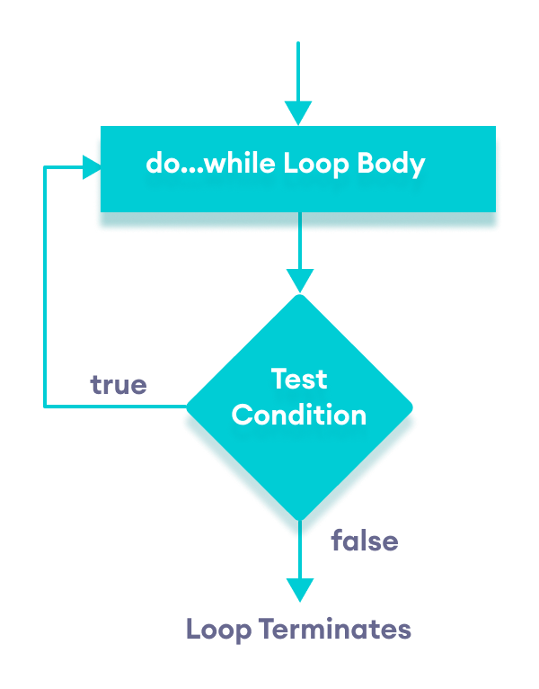Flowchart of Java do while loop

Let's see the working of do...while loop.

**Example 3: Display Numbers from 1 to 5**

// Java Program to display numbers from 1 to 5

import java.util.Scanner;

// Program to find the sum of natural numbers from 1 to 100.

class Main {

public static void main(String[] args) {

int i = 1, n = 5;

// do...while loop from 1 to 5

do {

System.out.println(i);

i++;

} while(i <= n);

}

}

[Run Code](https://www.programiz.com/java-programming/online-compiler)

**Output**

1

2

3

4

5

Here is how this program works.

| Iteration | Variable | Condition: i <= n | Action |
| --- | --- | --- | --- |
|  | i = 1 n = 5 | not checked | 1 is printed. i is increased to **2**. |
| 1st | i = 2 n = 5 | true | 2 is printed. i is increased to **3**. |
| 2nd | i = 3 n = 5 | true | 3 is printed. i is increased to **4**. |
| 3rd | i = 4 n = 5 | true | 4 is printed. i is increased to **5**. |
| 4th | i = 5 n = 5 | true | 6 is printed. i is increased to **6**. |
| 5th | i = 6 n = 5 | false | The loop is terminated |

**Example 4: Sum of Positive Numbers**

// Java program to find the sum of positive numbers

import java.util.Scanner;

class Main {

public static void main(String[] args) {

int sum = 0;

int number = 0;

// create an object of Scanner class

Scanner input = new Scanner(System.in);

// do...while loop continues

// until entered number is positive

do {

// add only positive numbers

sum += number;

System.out.println("Enter a number");

number = input.nextInt();

} while(number >= 0);

System.out.println("Sum = " + sum);

input.close();

}

}

[Run Code](https://www.programiz.com/java-programming/online-compiler)

**Output 1**

Enter a number

25

Enter a number

9

Enter a number

5

Enter a number

-3

Sum = 39

Here, the user enters a positive number, that number is added to the sum variable. And this process continues until the number is negative. When the number is negative, the loop terminates and displays the sum without adding the negative number.

**Output 2**

Enter a number

-8

Sum is 0

Here, the user enters a negative number. The test condition will be false but the code inside of the loop executes once.

**Infinite while loop**

If **the condition** of a loop is always true, the loop runs for infinite times (until the memory is full). For example,

// infinite while loop

while(true){

// body of loop

}

Here is an example of an infinite do...while loop.

// infinite do...while loop

int count = 1;

do {

// body of loop

} while(count == 1)

In the above programs, the **textExpression** is always true. Hence, the loop body will run for infinite times.

**for and while loops**

The for loop is used when the number of iterations is known. For example,

for (let i = 1; i <=5; ++i) {

// body of loop

}

And while and do...while loops are generally used when the number of iterations is unknown. For example,

while (condition) {

// body of loop

}